|  |
| --- |
| EncourageWork |
| A Homework Motivation Android Application |
| Cecilia Suderman |

Contents

Declaration 3

Definition 3

User Story 4

Use Cases 5

Use Case List 5

Use Case Diagram 5

Use Case Analysis 6

Use Case 1: View Assignment List 6

Use Case 2: Add Assignment 7

Use Case 3: Shake Device 8

Domain Classes 9

# Declaration

 I'm going to create a motivational homework app that will keep track of assignments. It'll congratulate you on assignments completed and offer encouraging words when you shake your phone in utter frustration. When you're really feeling overwhelmed and flip your phone face-down because you just can't stand to see that mountain of homework anymore, it'll play a comforting audio file.

# Definition

 My application, EncourageWork, will keep track of homework assignments while providing motivation and encouragement. The user will be able to input assignments and their due dates. The key here is simplicity; the user will not be able to track grades or their classes as I feel that would deter from the core goals of the application. Ideally, this application is more akin to a to do list. It will have a calendar view to provide an overview of due dates, allowing the user to see, at a glance, their workload for the week or month. A daily view will also be available that will provide a list of assignments due on one particular day. The user will be able to input different types of assignments (reading, studying, homework, projects, etc.) that will appear differently on the calendar so that the workload is not mistaken.  
 Equally important to its assignment tracking functionality is the motivational side of things. When an assignment is completed the app will congratulate the user on their accomplishment. If an assignment is late, the app will never nag or berate, just encourage if the assignment can be turned in late or drop it and comfort the user if not. When the user is very frustrated and shakes the phone, an encouraging message will appear. In the event that the user is completely overwhelmed with their workload and sets the phone face-down in exasperation, the app will play a soothing audio file. Overall, the key is simplicity; the app will act as a combination calendar/to do list with a motivational twist to help users keep track of their assignments and encourage them in the process.

# User Story

Blaster (yes, the burro, don't ask me how he got a phone or the ability to use it) is up to his eyeballs in homework being a Mines student and all (mascot-ing has some pretty high standards these days). There's just way too much going on and he's started to feel a little overwhelmed. The icing on the cake? He's been faced with so many incorrect answer boxes on Capa doing physics homework that he can't see the color Capa Red anymore without having a mental breakdown. Thinking there's an app for everything and there has to be something out there to help him, Blaster decides to try a goofy little homework app that motivates you as you go (because, though he won't admit it, he secretly wants someone to tell him everything is going to be okay). He downloads and installs the app and starts putting his assignments in with their deadlines and is surprised to find the app is already offering some small words of encouragement via an onscreen message every time he adds an assignment. As he explores the app further he notices that he can pull up a calendar view that gives him an overview of his daily, weekly, or monthly workload at a glance. "Really?" He thinks to himself, noticing something upsetting, "I have ten assignments due Tuesday?!" He shakes the app in frustration, which, another surprise, brings up another encouraging on-screen message. "Look phone, I just don't want to hear it from you right now, okay?!" He shouts at his phone while bystanders question his sanity. With huff of exasperation, he flips the phone face down, not wanting to look at that nasty workload for one more second. He jumps a foot when the phone starts playing Soft Kitty from The Big Bang Theory. He quickly picks up the phone, frustrated with the combination of shock, amusement, and comfort he's now feeling, and looks at the screen to find a chirpy "Hope that helped!" on screen. "Huh, well I do feel better..." he mutters to himself. Over the next few weeks he doesn't forget about a single assignment (good because that was really getting to be a problem and he hates planners) and every time he checks something off on the phone the app tells him how awesome he is and what a great job he's doing. It doesn't even judge him when he doesn't get something done (a trait he wished his nag of a mother shared); it just said something like, "You must have been busy. It's cool" or "Yeah, that was a dumb assignment anyway." Encouraged, better organized, and grateful to finally have a simple app to help that doesn't over-complicate things, Blaster finally starts getting his act together and getting his homework done.

# Use Cases

## Use Case List

1. Student views homework list
2. Student adds assignment
   1. Encouraging notification pops up when assignment is added
3. Encouraging notification pops up when Student shakes device
4. Encouraging audio file plays when device flipped face down
5. Student updates assignment
   1. Encouraging notification pops up when update is made
6. Student marks assignment complete
   1. Encouraging notification pops up when assignment is marked complete
7. Student views calendar view of homework

## Use Case Diagram

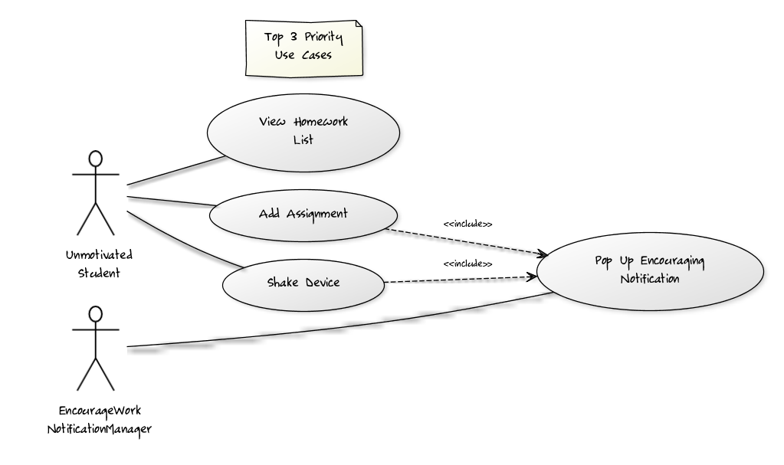

A larger version of this diagram is available at: <http://yuml.me/bf1cc29b>.

## Use Case Analysis

### Use Case 1: View Assignment List

**Main Success Scenario**

The Unmotivated Student using EncourageWork needs to be able to see an overview of the assignments that have been entered into the application. This is accomplished by the Assignment List screen, accessible from an option on the home screen of the application. As an overview, the Assignment List screen does not show every detail on every assignment entered, but instead the most condensed version possible. Assignments will show up as a list, with an icon on the left side of an entry to indicate its given priority and a checkbox on the right to allow Unmotivated Student to quickly and easily mark the assignment completed. Within the list entry, the assignment name and due date will be displayed. Each individual assignment can be edited by clicking on it, thus bringing up an editable detail view.

**Alternate Scenarios**

No Assignments Available

If the assignment database is empty, the Assignment List screen will instead display a centered text view indicating as much and congratulating the UnmotivatedStudent.

Too Many Assignments to View at Once

If there are so many assignments entered that there is not room to view them all at once, the Assignment List will not adjust in size. Instead it will scroll to accommodate the overflow.

### Use Case 2: Add Assignment

|  |  |
| --- | --- |
| **Title** | As an Unmotivated Student, I want to Add Assignment so that it will be displayed in the Assignment List and I won’t forget about it. |
| **Primary Actor** | Unmotivated Student |
| **Stakeholders & Interest** | Unmotivated Student wants to add an assignment. |
| **Preconditions** | Unmotivated Student selects “Add Assignment” from home screen, Assignment List, or calendar view |
| **Postconditions** | Assignment is saved to the database and an encouraging notification is displayed over the newly updated Assignment View screen |
| **Main Success Scenario** | 1. Unmotivated Student adds assignment to database |
| **Extensions** | * 1. Assignment could not be successfully saved to the database due to technical problems      1. Notification “Error saving assignment. Please try again” displayed   2. Required Assignment information not provided      1. Add Assignment view updated with error highlighting in form fields |
| **Special Requirements** | Error checking must exist within this form to ensure Unmotivated Student doesn’t try to save assignments to the database without required information (specifically, name and due date). |
| **Technology & Variation List** | Technical issues may arise when trying to read and write from database. |
| **Frequency** | Multiple times per session, as requested by Unmotivated Student. |
| **Open Issues** | How can the database be better protected? |

### Use Case 3: Shake Device

**Main Success Scenario**

At any time while the application is both running and has focus (is not running in the background on the device, but it is instead being actively used), the Unmotivated Student user may shake the device. This occurrence should result in a notification popping up, offering encouraging words to soothe the presumably stressed Unmotivated Student. The Unmotivated Student may click anywhere on screen or the back button to close this notification. Any subsequent device shakes have the same result.

# Domain Classes

|  |  |
| --- | --- |
| **Assignment** | Homework assigned to the Unmotivated Student that need be kept track of and the completion of which is highly encouraged |
| **Device Shake** | Unmotivated Student shakes the device (subtly or violently), the occurrence of which need be detected by the application, resulting in a Notification |
| **Device Face Down** | Unmotivated Student turns the device face down for whatever length of time, an event that also requires notice and results in the playing of an Audio Clip |
| **Notification** | An important message for Unmotivated Student, delivered with high priority by the device via text popping up on screen |
| **Audio Clip** | A notification delivered not visually, but audibly to Unmotivated Student |